ENGE600 Semester II Assessment: Pike River Technical Case Study Theoretical Application

On the 19th November, 2010 a series of methane explosions at the Pike River Coal Mine, situated outside Greymouth, killed 29 workers. Two miners managed to walk from the mine; they were treated for moderate injuries and released from Greymouth Hospital the next day. The remaining 16 miners and 13 contractors, often referred to as the twenty-nine, were believed to be at least 1,500 metres (4,900 ft) from the mine's entrance. While contact with the trapped miners was attempted and rescue and medical teams quickly arrived on site, no evacuation was attempted due to high temperatures and poisonous chemical levels. Following a second explosion on 24 November at 2:37 pm, the 29 remaining men were believed by police to be dead. At the time of the explosion, out of a workforce of 200, there were over 80 independent contractors employed. Pike River Coal Mine Ltd (PRCM) not only subcontracted manual labour (skilled and unskilled), the company also outsourced aspects of the mine design, financial and environmental risk assessments, and a great deal of the management of occupational health and safety (OHS) such as mine ventilation.

The New Zealand mining industry
New Zealand mining conditions are typically complex and characterised by faulted and dipping coal seams. The New Zealand coal mining industry is small. Annual production is about 5 million tonnes – approximately 2% of Australia’s production. In 2010 fewer than 2000 people were working in 22 coal mines, only five of which were underground. Pike River was developed as an underground mine, because open cast mining was not economic owing to the depth of the Brunner coal seam.

The Technical Development of Pike River Coal Mine
PCRM was formed in 1982 and acquired by New Zealand Oil & Gas Ltd (NZOG) in 1998. Over a 13-year period PCRM explored and then acquired the necessary authorisations for the mine, including a mining permit, an access arrangement and resource consents. Initial exploration indicated a recoverable coal reserve of 19 million tonnes of high-quality hard coking coal. In 2005 the Pike board decided to proceed with development of the mine. By May 2007 Pike offered shares in the company and assigned 85 million one-dollar shares to over 5000 new investors. NZOG remained the major shareholder, but no longer held a controlling interest. Development costs were estimated at $124 million, with annual coal production of more than a million tonnes projected by 2008.

PRCM faced many challenges developing a new mine in a mountainous area with difficult geological conditions. The company’s knowledge of the geology and the extent and location of the coal seam was based on an initial 14-borehole exploration programme, supplemented by a similar number of boreholes drilled subsequently. These provided insufficient geological information, which led to adverse unexpected ground conditions hindering mine development. Construction of the drift took much longer than anticipated. Delays were caused by a downthrust between faults (called a graben), which created a zone of sandstone instead of coal, and the collapse of the bottom section of the ventilation shaft during construction. The collapse meant that a bypass had to be built to reconnect to the upper part of the shaft about 50m above pit bottom.
Development costs escalated over the $143 million figure projected in 2007. PCRM required capital and during 2010 it raised $140 million from shareholders, was seeking another $70 million as at 19 November and also borrowed $66 million from New NZOG. The first coal sales totalling 42,000 tonnes, were delayed until 2010; and the lower volume and quality of the coal continued. Throughout 2010 the management team faced planning changes and operational challenges, including improving coal production, establishing the hydro panel, commissioning the new main underground fan, upgrading the methane drainage system and resolving problems with mining machinery. These coincided with the drive to achieve coal production. In September 2010 PRCM started mining in the hydro panel close to pit bottom. When hydro mining began, the Pike River employees were offered the incentive of a $13,000 bonus if they met production targets by late September, after which the payment would decrease from week to week. Despite a number of set-up problems the targets were met towards the end of the month.
In October the width of the extraction area was increased from 30m to 45m, although a consultant geotechnical engineer had indicated the risk of a major roof collapse in the goaf could not be excluded. On 30 October a significant roof fall did occur, causing a pressure wave that took out the stopping in the hydro cross-cut intended to separate intake and return air. Methane readings were high, but there was no explosion. Hydro mining continued into November without reassessment of the risk of further roof falls in the goaf. Production levels did not improve, and spikes in the methane levels continued to be recorded in the weeks leading up to the explosion. After the new fan was commissioned, ventilation to the hydro panel improved and during October 2010 hydro mining became a two-shift, 24-hour operation. Substantial overtime was offered.
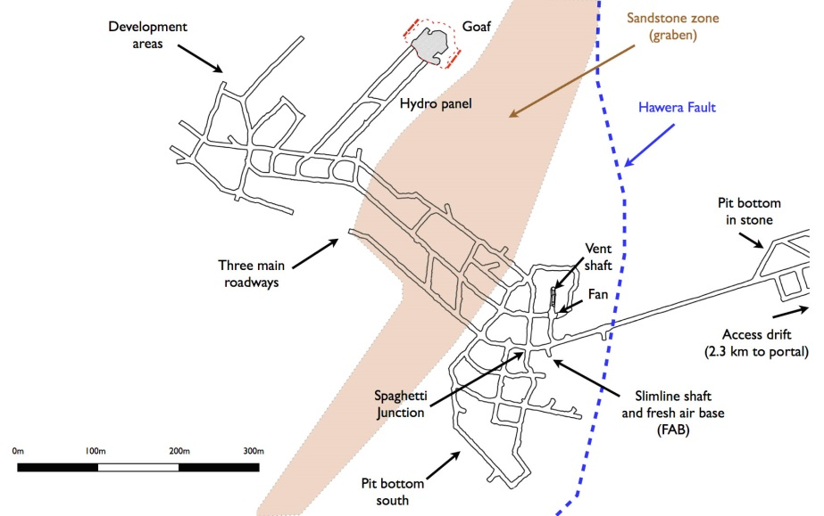

Figure 1: The mine plan as at November 2010

Ventilation
PRCM’s long-term mine plan had been to develop roadways to the north-west corner of the mine, establish a second intake and begin hydro mining in that area, and for mining to retreat back to pit bottom over the life of the mine – approximately 19 years. The second intake, had it been developed, would have doubled as a walkout egress from the mine and also improved the efficiency of the ventilation system. The original mine plan specified two main fans located on the mountainside next to a ventilation shaft. However the company decided to relocate the fans underground in stone at the bottom of a ventilation shaft. Placing a main fan underground in a gassy coal mine was a world first, where it could not be reached in the event of a disaster. The fan's motor and other items of electrical equipment underground were not designed to be flameproof, and could operate only in fresh air. Despite early plans to pre-drain methane from the coal seam before mining began, this hadn't happened. Instead, gas was bled out of the seam from the in-seam drill holes that the company relied on to find out where the coal seam lay, and drained through a pipeline the company knew to be inadequate and overpressured.
A ventilation consultant and some Pike staff voiced opposition, but the decision was not reviewed. The fan significantly increased Pike’s ventilation capacity, at least in the short term. The board received a monthly report containing a health and safety section. It did not cover the hazards relevant to a catastrophic event such as an explosion. The board did not assess critical design and health and safety issues. The mine manager attended a board meeting four days before the explosion and told the directors that gas management was ‘more a nuisance and daily operational consideration than a significant problem or barrier to operations’. The board was not well placed to assess this assurance given their lack of operational knowledge. Pike’s mine management plans and procedures needed considerable attention. The health and safety management plan was largely in draft, partly while awaiting technical input from other managers.
The investigation of incident reports was haphazard, with the result that in October 2010 a backlog of outstanding investigations was written off. Other information from underground, including methane readings from fixed and portable sensors, was not systematically analysed and the problems addressed. "In the 48 days before the explosion there had been 21 reports of methane levels reaching explosive volumes, and 27 reports of lesser, but potentially dangerous, volumes of the gas," the Royal Commission into the Pike River Coal Mine Tragedy noted. "The reports of excess methane continued up to the very morning of the tragedy. The warnings were not heeded."
The area most likely to contain a large volume of methane was a goaf formed during mining of the first coal extraction panel in the mine. It is also possible that methane which had accumulated in the working areas of the mine fuelled the explosion, or at least contributed to it. Potential ignition sources include arcing in the mine electrical system, a diesel engine overheating, contraband taken into the mine, electric motors in the non-restricted part of the mine and frictional sparking caused by work activities. The main fan was not explosion protected and failed in the explosion. A back-up fan at the top of the ventilation shaft was damaged in the explosion and did not automatically start as planned. The ventilation system shut down.
Conclusion
- The Royal Commission into the Pike River Coal Mine Tragedy found in November 2012 that this was a process safety accident, being an unintended escape of methane followed by an explosion in the mine. It occurred during a drive to achieve coal production in a mine with leadership, operational systems and cultural problems.
- Such problems coincided with inadequate oversight of the mine by a health and safety regulator (Department of Labour) that lacked focus, resourcing and inspection capacity.
- At the executive management level there was a culture of ‘production before safety’ at Pike River and as a result signs of the risk of an explosion were either not noticed or not responded to.
Shortly after the explosions at Pike River Coal Mine (PRCM), the mine was closed and the company went into receivership. As most of the independent contractors were unsecured small creditors, neither they nor their workers or their families received any money owed to them by Pike River Coal Mine Ltd (in receivership). It is estimated that unsecured creditors, including the independent contractors are owed $(NZ)31m, with another $20.5m owed to Pike's major shareholder and secured creditor, New Zealand Oil and Gas.

References

New Zealand Parliament Hansard (debates) (2012, 6 November). Urgent Debates — Pike River Mine Disaster—Release of Report, Government Response, and Ministerial Resignation. Found at:
http://www.parliament.nz/en-nz/pb/debates/debates/50HansD_20121106_00000008/urgent-debates-%E2%80%94-pike-river-mine-disaster%E2%80%94release-of-report
MacFie, R. (2013, 16 November). Tragedy at Pike River Mine. Found at: http://www.stuff.co.nz/the-press/news/west-coast/9407313/Book-Excerpt-Tragedy-at-Pike-River-Mine
Royal Commission into the Pike River Coal Mine Tragedy (2012). Commission’s report- Volume One. Found at:
http://pikeriver.royalcommission.govt.nz/Volume-One---What-Happened-at-Pike-River

Royal Commission into the Pike River Coal Mine Tragedy (2010). Found at: http://pikeriver.royalcommission.govt.nz/

This is an uncommon and specialised mining technique that uses a water jet to cut the coal face and requires expert design of the mining panel and equipment. An insurance risk survey received in July 2010 identified serious concerns about the hazards posed by hydro mining, windblast and a gas explosion, and urged the need for a comprehensive risk assessment of the mining operation. Neither the board nor its committee saw the report.
Ventilation consultants advised Pike on an as required basis, but no one at the mine had dedicated responsibility for ventilation management.
There was only one mines inspector for the whole of the country. DoL had a vacancy but could not find a replacement. That single inspector was also responsible for checking the thousand or so quarries throughout New Zealand.

